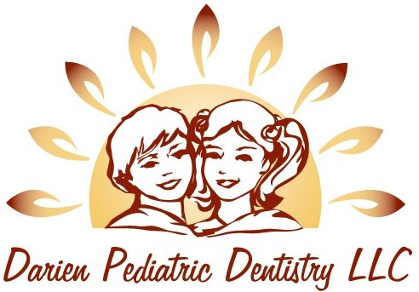

COVID-19 Patient Screening and Consent Form

I ----------------------------------------, knowingly and willingly consent to have my child’s prophylactic and urgent dental treatment performed at Darien Pediatric Dentistry, LLC during the COVID-19 pandemic.
I understand that the COVID-19 virus has a long incubation period during which carriers of the virus may not show symptoms but still be contagious. It is impossible to completely rule out the exposure to the virus from the staff or other patients and parents who may be asymptomatic carriers.

Name of the children:
Relationship to the children:
Parent’s signature:
Today’s Date:

I confirm that neither I nor my children are presenting with any of the following symptoms today:
- Fever
- Shortness of breath
- New loss of sense of taste or smell
- Cough
- Runny nose
- Sore throat
- Flu like symptoms such as gastrointestinal upset, headache or fatigue
- Have not traveled in the past 14 days to any COVID-19 hot spots
- Have not been in contact with any confirmed COVID-19 patients

Parent’s Signature:
Date:

